Policy No. 2023-24
Adopted: Date Revised:__________________
MEMORIAL POLICY
The Anderson Island Historical Society

The purpose of this Policy is to define the policy of AIHS in regard to memorials.
1.0 General
For the purposes of this policy, a memorial is any modification of AIHS property that is made to remember or commemorate an AIHS member or contributor. Memorials can be permanent (such as a bench), or temporary (such as a temporary display).
This policy does NOT address memorial services or events that are held on AIHS premises. These are addressed in the AIHS Private Event policy and AIHS Archival Building policy.
2.0 Permanent Memorials
Permanent memorials are permanent modifications to AIHS property.

Adopted by AIHS Board of Directors, Date: _____________
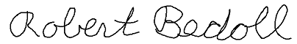
Robert Bedoll, AIHS President. ________________

