Policy No. 2022-24
Adopted: 10/19/22 Revised:__________________
THEFT POLICY
The Anderson Island Historical Society

The purpose of this Policy is to define the policy of AIHS to thefts.
1.0 General
AIHS membership may be revoked or denied based on evidence of theft, vandalism, harassment, and or threatening behavior on Johnson farm property.

Adopted by AIHS Board of Directors, Date: 10/19/2022
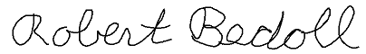
Robert Bedoll, AIHS President. 10/19/2022

