Policy No.2009-7 Adopted April 8, 2009

CONFLICT OF INTEREST
POLICY
Of
Anderson Island Historical Society
9306 Otso Point Road
Anderson Island, Washington 98303
http://www.andersonislandhs.com/

"We, the Officers and Directors of the Anderson Island Historical Society, hereafter "the Board", resolve that no member of the Board shall participate in any discussion or vote on any matter in which he or she or a member of his or her immediate family has potential conflict of interest due to having material economic involvement regarding the matter being discussed. When such a situation presents itself, the director must announce his or her potential conflict, disqualify himself or herself, and be excused from the meeting until discussion is over on the matter involved. The President of the meeting is expected to make inquiry if such conflict appears to exist and the board member has not made it known."

Reviewed and Approved by the AIHS Policy Review Committee, 4/10/2019.
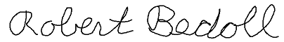
President, Anderson Island Historical Society. April 4, 2019.

Anderson Island Historical Society is a 501(c)(3) non-profit organization

